Oracle Administration Services

Oracle 11g to 12c Manual Upgrade

Submitted to



By



CIS, Wipro Limited

Document Details

Project Name | Innogy SE
Account | CIS
IT Component/Application Title | Oracle 11g to Oracle 12c Manual Upgrade
Current Version | 1.3
List of Contributors | Ajay Zende, Sreya Puthukudy
Customer Contact Information

Version History
(All revisions made to this document must be listed in chronological order. All revisions must be approved. Review and Approval can be done by an internal source or by the customer)
Version | Date of Revision | Description | Author | Reviewed By | Approved By
1.0 | 16-11-2017 | Initial Draft | Ajay Zende | Jiten Pansara | Santosh Badiger
1.1 | 25-11-2017 | Document Completed | Ajay Zende | Jiten Pansara | Santosh Badiger
1.2 | 25-11-2017 | Document Completed | Ajay Zende | Jiten Pansara | Santosh Badiger
1.3 | 27-12-2018 | Updated the content | Sreya Puthukudy | Jiten Pansara | Santosh Badiger

Document Distribution List
S.No | Name and Company | Purpose
1 | RWEIT-ORACLEDBA | This document provides information related to Manual Upgrade of Oracle Software from 11g to 12c in a step wise manner
2

TABLE OF CONTENT
1. Purpose 5
2. Scope 5
3. Pre Upgrade Process 5
4. Upgrade Process 8
5. POST Upgrade Process 9

Purpose
This document is prepared for providing information in terms of the steps to be followed for Oracle 11g upgrade to 12c.

Scope
The document can be used in a stepwise manner to pre-task (Prerequisites ) of Oracle upgrade, upgrade process ( Actual Steps of upgrade ) and Post task once done with upgrade.

Pre-Upgrade Process

3.1 Supported Upgrade Paths
Direct upgrades to 12c are possible from existing databases with versions 10.2.0.5+, 11.1.0.7+, or release 11.2.0.2+. Upgrades from other versions are supported only via intermediate upgrades to a supported upgrade version

3.2 Oracle 12c Software Installation
Oracle 12c Software must be installed on mentioned server to minimize downtime window. SOP of Oracle 12c installation can be referred for the same.

3.3 Backup Database
Full Database Backup Should be taken prior to proceed of this activity. This is for back-out plan in case of failure.

3.4 Pre-Upgrade scripts
Copy the "preupgrd.sql" and "utluppkg.sql" scripts from the Oracle 12c home to a location accessible by the database that needs upgrading. In this example I used a directory under "/tmp".

$ mkdir -p /tmp/upgrade
$ cp /Oracle/TEST/12.1.0.1/rdbms/admin/preupgrd.sql /tmp/upgrade
$ cp /Oracle/TEST/12.1.0.1/rdbms/admin/utluppkg.sql /tmp/upgrade

Execute these copied scripts on Oracle 11g Environment
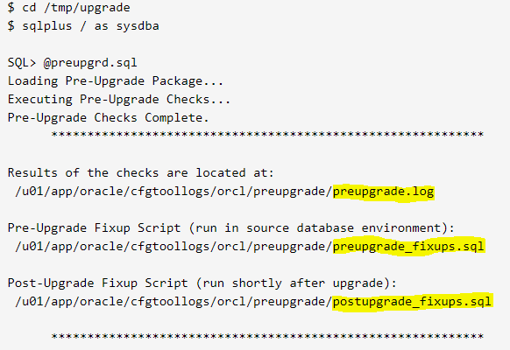

The Pre-Upgrade Information Tool produces 3 scripts.
preupgrade.log: The results of all the checks performed. You need to check this to see if it is safe to continue with the upgrade.
preupgrade_fixups.sql : A fixup script that should be run before the upgrade.
postupgrade_fixups.sql : A fixup script that should be run after the upgrade.

If there is no Errors in the "preupgrade.log" file,
run the "preupgrade_fixups.sql" script.
Any changes script unable to perform are marked as "MANUAL ACTION SUGGESTED".
e.g
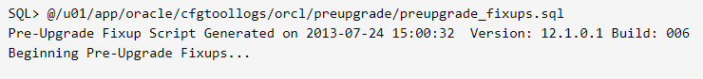
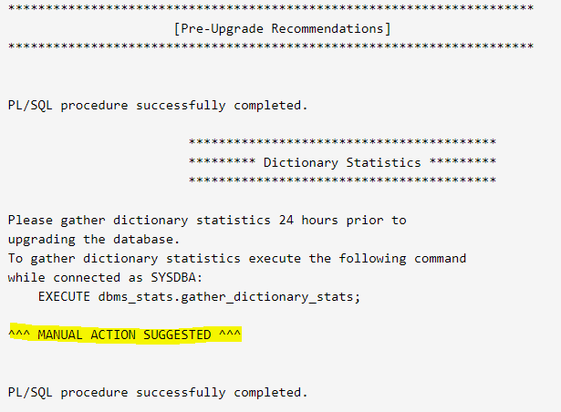

Then go ahead and do suggested changes ( gather DB statistics )

3.5 Copy Files from Oracle11g to Oracle 12c env
Copy init.ora and password file to Oracle 12c env
$ cp /Oracle/TEST/11.2.0.3/dbs/initTEST.ora /Oracle/TEST/12.1.0.1/dbs
$ cp /Oracle/TEST/11.2.0.3/db_1/dbs/orapwdtest /Oracle/TEST/12.1.0.1/dbs

Upgrade Process
Make sure the environment is set to the 12c home.

Env|grep ORA
Start the database in upgrade mode
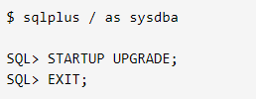

Run the new Parallel Upgrade Utility (catctl.pl).
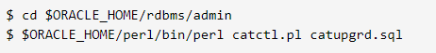
It will take time, once completed check log
Startup the upgraded database and run the "utlu121s.sql" script
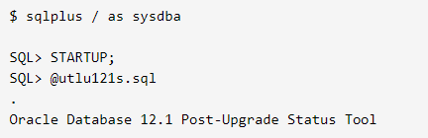

Post Upgrade Process
If the "postupgrade_fixups.sql" file contained any recommendations, run it now
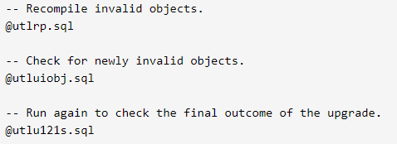

Database upgraded sucessfully to Oracle 12c

